Intermediate

09 April 2025

11:51

* + Intermediate course:
    - lists:
      * list.append("value")
      * list.clear() : clears all the value and returns empty list
      * list.insert(position, value)
      * list.reverse() : order gets reversed
      * list.sort() : in ascending order
      * new_list = sorted(old_list) : doesn't change old list
      * list = [0] * 5 : [0,0,0,0,0]
      * list = list1 + list2
      * list = my_list[1:5] : 1 to 4 copied
      * [:5] : start from beginning
      * [::2] : step 2 value, [::-1] to reverse the list
      * list_cpy = list_org : will affect orginial list (same memory)
      * list_cpy = list_org.copy() : same as list(list_org), list_org[:]
      * list_sqr = [ I * I for I in list]
      * index out of range error possible
      * remove() through error if not found

* + Tuples: ordered, immutable
    - mytuple = ( "max" , 28 ) : same as mytuple = "max", 28
    - tuple = ("max", ) : for one element
    - type(variable_name)
    - index out of range error possible
    - mytuple[0] = "madhu" : not possible
    - if "max" in tuple :

print("Yes")

else:

print("no")

//possible

* + print(len(my_tuple))
  + print(my_tuple.count('Madhu')) : shows the no. of Madhu present
  + my_tuple.index('l') :value error if not found
  + my_list = list(my_tuple) : changed to modify and use tuple() function
  + slicing is possible my_tuple[3:5] : default step 1
  + name, age, city = my_tuple : valueError if nos. doesn't match
  + *age used for unpacking and in excess converted to list
  + Large data sets are faster in tuples than list
    - import timeit

print(timeit.timeit(list_name, number = '100000' )) : will get the time required for making this list/array {list = tuple*16}

* + sys.getsizeof(array_name) : list>tuples

* + Dictionary: Key-value pair, mutable, unordered
    - mydict = { "name" : "Max" , "age" : 28 , "city" = "New York" }
    - dict( name="Max", city = "Boston", age = 38) : no quotes for keys
    - my_dict["last_name"] :will through error if not present
    - my_dict["email"] = "madhu.com" : updating values
    - del my_dict["key name"]
    - mydict.pop("key name")
    - mydict.popitem() : will delete the last inserted item
    - if "name" in mydict:

print(mydict["name"]) // will produce error if not present

* + try:

print(mydict["name"])

except:

print("error")

* + for key in mydict:

print(key)

for key in mydict.keys():

print(key)

//both are the same

* + for key, value in mydict.items(): : for getting both key and value
  + my_dict_cpy = my_dict : will affect the original
  + So : dict(my_dict) or my_dict.copy()
  + mydict.update(mydict2)

* + my_dict = { 3:9 , 6:36, 9:81 }

value = my_dict[3] //produces value 9

* + keys can be tuple but not list as they are mutable
  + Sets: unordered , mutable, no duplicates inside
    - myset = set("Hello") : {'l', 'o', 'H', 'e'} and no 2 l's are present
    - myset.add(3) : will add to set
    - myset.discard(5) : no error if not present
    - myset.pop() : possible
    - Itteration:

for I in myset:

print(i)

* + if 1 in myset:

print( "yes")

* + u = odds.union(evens) : all numbers
  + I = odds.intersection(evens) : empty set
  + diff = setA.difference(setB)
  + diff = setA.symetric_difference(setB) will give (A U B) - (A intersection B)
  + Last 4 returns values and no updation
  + setA.update(setB) will add A with unique elements
  + setA.intersection_update(setB)
  + setA.difference_update(setB)
  + setA.symmetric_difference_update(setB)
  + print(setA.issubset(setB)) : setA a subset of setB or not?
  + setA.issuperset(setA) :
  + setA.isdisjoint(setB) : checks for no element
  + setA = setB : will make a link
  + So : setA = setB.copy() or set(setB)
  + a = frozenset([1, 2, 3, 4]) : can't add or remove but union will work
  + String:
    - "Hello World" : 'string' : 'string\'s' : or """ multi line """" or : " ' " // will print single quotes inside
    - my_string[0] : indexing
    - my_string[0] = 'h' : error immutable
    - substring = string [1:5] : slicing(step value is also present)
    - name = "Tom " + greeting : concatination( space is required)
    - for I in greeting:

print(I ) //will print all the elements in string

* + if 'e' in greeting:
  + my_string = my_string.strip() : as strings are immutable
  + my_string.lower() : .upper() : .startswith("char_or_word") : endswith()
  + my_string.find('o') : first index of occurance
  + my_string.count('o')
  + my_string.replace('Old_word', "new_word") : does not change the original string
  + my_string = "How are you doing"

my_list = my_string.split()

//demeliter is space. : my_string.split(",") for csv files

new_string = ''.join(my_list) // without any space if we need space for all elements use ' '.join(my_list)

* + from module import function as new_name_for_function
  + Formating:
    - %, .format() and F strings
    - my_string = " Hello %s" %var

%d (decimal: truncates if floating), %.3f (floating: by default 6 point for floating values)

* + my_string = "Hello {:.2f} ".format(var)
    - var is a default value as float which :.2f is for 2 decimal places
    - "{} and {} ".format(var,var2) for multiples place holders
  + my_string = f"the variables is {var} and {var2}"
    - F strings are faster as they get evalutes at run time
  + Collections Module:
    - Counter: stored as dict

from collections import Counter

a = "aaaaabbbcccc"

my_counter = Counter(a)

print(my_counter) // will give all the key value pairs //my_counter.keys()

print(my_counter.most_common(2)) //will give 2 most used letters

* + namedtuple:

from collections import namedtuple

Point_cal = namedtuple('Point','x,y')

pt = Point_cal(1,-4)

print(pt.x , pt.y) //prints the coordinates

* + OrderedDict

from collections import OrdereDict

ordered_dict = OrderedDict()

ordered_dict['a'] = 1

ordered_dict['b'] = 2

ordered_dict['c'] = 3

print(ordered_dict) // will always maintain the order and does not change

* + defaultdict: sets a default value for key if not given

from collections import defaultdict

d = defaultdict(int)

d['a'] = 1

d['b'] = 2

print(d['c']) // will print 0 as the default value is integer and does not produce error // float : 0.0 // list : []

* + deque:

from collection import deque

d = deque()

d.append(1)

d.append(2)

d.appendleft(3) // will append elements to left side

d.pop() //d.popleft()

d.clear() // clears all element

d.extend([4, 5 , 6]) //extendleft() and 6 would be the very left element in the list

d.rotate(1) //shift all element 1 place to the left negative numbers also given

* + Itertools: Used in for loop
    - product:

from itertools import product

a = [ 1, 2 ]

b = [ 3, 4 ]

prod = product(a, b, repeat = 2)

print(list(prod))

* + when b = [3] alone as the repeat value is 2

[(1, 3, 1, 3), (1, 3, 1, 4), (1, 3, 2, 3), (1, 3, 2, 4),

(1, 4, 1, 3), (1, 4, 1, 4), (1, 4, 2, 3), (1, 4, 2, 4),

(2, 3, 1, 3), (2, 3, 1, 4), (2, 3, 2, 3), (2, 3, 2, 4),

(2, 4, 1, 3), (2, 4, 1, 4), (2, 4, 2, 3), (2, 4, 2, 4)]

* + permutations:

from itertools import permutations

a = [1, 2, 3]

perm = permutations(a)

print(list(perm))

* + permutations(a , 2) can be given for ordered sets of 2
  + [(1, 2, 3), (1, 3, 2), (2, 1, 3), (2, 3, 1), (3, 1, 2), (3, 2, 1)]

* + combinations:

from itertools import combinations

a = [1, 2, 3, 4]

comb = combinations(a,2)

print(list(comb))

* + when used combination with replacement function (1,1) and the respective elements will be added
  + accumulates: sums

from itertools import accumulate

a = [1, 2, 3, 4]

acc = accumulate(a)

print(a)

print(list(acc))

* + acc = accumulate(a, func = operator.mul)
  + acc = accumulate(a, func = max)
  + groupby:

from itertools import groupby

def greater_than_3(s):

return s>3

a = [1, 2, 3, 4]

group_obj = groupby(a, key=greater_than_3)

for key, value in group_obj:

print( key, list(value))

* + count,cycle and repeat:

from itertools import count

for I in count(10): // starting value of index

print(i)

if I == 15:

break

* + Output:

10

11

12

13

14

15

* + cycle(list) is to loop any list infinitely until break conditions
  + repeat(1) will infinetly get the value 1

* + How to capture time for a step:
    - from timeit import default_timer as timer

start = timer()

<code>

stop = timer()

print(stop - start)

* + Lambda :: one line function without name

add10 = lambda x:x+10

print(add10(5))

mult = lambda x,y : x*y

print(mult(2,7))

* + Using sorted functions:

points2D = [(1,2) , (15,1) , (5,-1)]

points2D = sorted(points2D, key = lambda x : x[1])

// will print the in ascending order with y coordinates( in key not mentioned with x coordinates)

a = [1, 2, 3, 4]

b = map(lambda x : x*2, a) // b= [x*2 for x in a]

print(list(b)) //list(b) is important

c = filter(lambda x : x%2 == 0 , a) //only even number// c = [x for x in a if x%2 ==0]

* + reduce::

from functools import reduce

a = [1, 2, 3, 4]

product_a = reduce (lambda x,y : x*y , a)

print(product_a) //24

* + Errors and exceptions:
    - TypeError: a= 5 + '10'
    - ModuleNotFoundError : if module is wrong
    - NameError : b = c // without defining c
    - FileNotFoundError : no file exists
    - a = [1, 2, 3, 4]

a.remove(5) //ValueError

* + a[5] //IndexError
  + my_dict = { 'name' : 'Max' }

my_dict['age'] //KeyError

* + Code:

x = -5

if x<0:

raise Exception('x should be positive')

//assert (x>0), 'x is not positive' ////will through an error msg if condition not satisfied

try :

a= 5/0

except : //except Exception as error_msg: //// will capture the error for printing

print('an error happened')

except ZeroDivisionError as e:

print(e )

except TypeError as e:

print ( e )

else :

print( "everything is fine")

finally:

print("cleaning up …")

* + Defining exceptions:

class ValueTooHighError(Exception) :

def __init__(self, message, value):

self.message = message

self.value = value

def test_value(x):

if x > 100:

raise ValueTooHighError('value is too high', x)

if x< 10 :

raise ValueTooLowError('value is too low', x)

try:

test_value(200)

except ValueTooHighError as e:

print(e )

except ValueTooLowError as e:

print(e.message, e.value)

* + Logging:

import logging

logging.debug("This is a debug message")

//.info

.error

.warning

.critical

//only .error , .warning , .critical msg will be displayed

// can add time ,level name, format for date and time, and error msg : refer logging.basicConfig()

* + IN main.py file:

import logging

logger = logging .getLogger(__name__)

//logger.propagate = False ////this won't allow the helper module to access this file , default = True

logger.info('hello from helper')

IN helper.py file:

import logging

logging.basicConfig(level = logging.DEBUG)

import helper

//Output: helper - INFO - hello from helper

Example 2:

import logging

logging.basicConfig(level=logging.DEBUG)

logging.debug('This is a debug message')

logging.info('This is an info message')

logging.warning('This is a warning message')

logging.error('This is an error message')

logging.critical('This is a critical message')

//this will print all the msgs as the level is set to DEBUG

* + Log handler:
    - import logging

logger = logging.getLogger(__name__)

#Creating handler

stream_h = logging.StreamHandler()

file_h = logging.Filehandler("file.log")

#level and the format

stream_h.setLevel(logging.WARNING)

file_h.setLevel(logging.ERROR)

formatter = logging.Formatter("%(name)s - %(levelname)s - %(message)s")

stream_h.setFormatter(formatter)

file_h.setFormatter(formatter)

logger.addHandler(stream_h)

logger.addHandler(file_h)

logger.warning('this is a warning')

logger.error('this is an error')

# this will create 'file.log' file to store error msg's and not warning as they were not mentioned and both will be displayed in the terminal

#can be done using config files also

* + logging using try and except:
    - import logging

try:

a = [1, 2, 3]

val = a[4]

except:

logging.error(e, exc_info = True # will include the stack trace {for all details})

# same can be done using traceback method

# RotatingFileHandler used for different log files based on the memory constraints of each log file generated

#time.sleep(5) will stop the code for 5 seconds

* + JSON :: (java script object notation)
    - Encoding:(converting dict to object)
      * import jsom

person = { "name" : "John" and some other values}

personJSON = json.dumps(person, # indent = 4 will set spaces between 2 key value pair)

print(personJSON)

with open ('person.json' , 'w' ) as file:

json.dumps(person, file) # will create a person.json file and dump person dict as object inside it

json.load(file) # in 'r' mode will get the data from json file to python

* + Random Numbers:
    - Pseudo Random numbers:

import random

a = random.random()#0 to 1

print(a)

#random.uniform(1,10): float value

#random.randint(1,10) : also include 10

#random.randrange(1,10) : doesn't include 10

#random.normalvariate(0, 1) : mean 0, variance 1

* + Get a random character from a string:

mylist = list("ABCDEFGH")

a = random.choice(mylist)

print(a)

* + Get a list of (length=3) random characters from string (without duplicate):

mylist = list("ABCDEFGH")

a = random.sample(mylist, 3)

print (a)

* + Get a list of (length=3) random characters from string (with duplicate):

mylist = list("ABCDEFGH")

* + a = random.choices(mylist, k=3)
  + print(a)
  + Shuffle a given list :
    - random.shuffle(mylist)
    - print(mylist)

* + How to get the random value multiple times?
    - random.seed(1)
    - print(random.random())
    - random.seed(1)
    - print(random.random()) // will get the same values if we same seed value. But is not good in terms of security
  + How to make true random values:
    - Use secrets module : import secrets

* + Make a random matrix with random values:
    - import numpy as np

a = np.random.randint(0,10,(3,5))

print(a) //will get a [3*5] matrix with values in the 1 to 10

* + Shuffle just the x-axis components of list:

import numpy as np ##Also has seed values

arr = np.array([ [1,2,3], [4,5,6], [7,8,9] ] )

np.random.shuffle(arr)

print(arr)

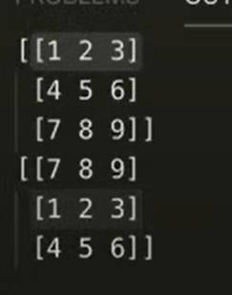

* + Decorators:(Add new functionality to a already existing function)

Examples: Add time of execution, debug, get more conditions satisfied

Basic sytax:

* + def start_end_decorator(func):

def wrapper():

print("Start")

func()

print("End")

return wrapper

def print_name():

print("Madhu")

print_name_with_decorator = start_end_decorator(print_name)

print_name_with_decorator()

Output: Start

Madhu

End

* + def start_end_decorator(func):

def wrapper():

print("Start")

func()

print("End")

return wrapper

@start_end_decorator

def print_name():

print("Madhu")

print_name()

// will aslo give the same result as above

* + Add input values inside function decorator:

def start_end_decorator(func):

def wrapper(*args, **kwargs):

print("Start")

result = func(*args, **kwargs)

print("End")

return result

return wrapper

@start_end_decorator

def add5(x):

return x+5

result = add5(10)

print(result)

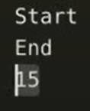

* + Decorators can also get values:

def repeat(num_times):

    def decorator_repeat(func):

        def wrapper(*args, **kwargs):

            for _ in range(num_times):

                func(*args, **kwargs)

        return wrapper

    return decorator_repeat

@repeat(num_times=3)

def greet(name):

    print(f"Hello, {name}!")

greet("Alice")

OUTPUT:

Hello, Alice!

Hello, Alice!

Hello, Alice!

* + Using functools for preserving data :

import functools

def start_end_decorator(func):

@functools.wraps(func)

def wrapper(*args, **kwargs):

print("Start")

result = func(*args, **kwargs)

print("End")

return result

return wrapper

@start_end_decorator

def add5(x):

"""Adds 5 to the input."""

return x + 5

print(add5.__name__) # Output: add5

print(add5.__doc__) # Output: Adds 5 to the input.

* + import functools

def repeat(num_times):

def decorator_repeat(func):

@functools.wraps(func)

def wrapper(*args,**kwargs):

for _ in range (num_times):

result = func(*args, **kwargs)

return result

return wrapper

return decorator_repeat

@repeat(num_times=3)

def greet(name):

print(f'Hello {name}')

greet("Alex")

* + Another Example:

import functools

def start_end_decorator(func):

@functools.wraps(func)

def wrapper(*args, **kwargs):

print("Start")

result = func(*args, **kwargs)

print("End")

return result

return wrapper

def debug(func):

@functools.wrap(func)

def wrapper(*args, **kwargs):

args_repr = [repr(a) for a in args]

kwargs_repr = [f"{k} = {v!r}" for k,v in kwargs.item()]

signature = ", ".join(args_repr + kwargs_repr)

print (f"Calling {func.__name__}({signature})")

result = func(*args, **kwargs)

print (f"{func.__name__!r} returned {result!r}")

return result

return wrapper

@debug

@start_end_decorator

def say_hello(name):

greeting = f'Hello {name}'

print(greeting)

return greeting

greet('Alex')

#repr(a) is a built-in function that returns a string representation of the object a. This representation is often useful for debugging because it includes information about the type and value of the object.

#v!r applies the repr function to the value v, producing a string representation of v.

* + Output:

Calling say_hello('Alex')

Start

Hello Alex

End

'say_hello' returned 'Hello Alex'

* + Class Decorator:

class CountCalls:

def __init__(self,func):

self.func = func

self.num_calls = 0

def __call__(self, *args, **kwargs):

self.num_calls +=1

print(f"This is executed {self.num+} times")

return self.func(*args, **kwargs)

@CountCalls

def say_hello():

print('Hello')

say_hello()

say_hello()

* + Output:
    - This is executed 1 times

Hello

This is executed 2 times

Hello

* + Generators:
    - return a object when asked for and can iterate inside and more efficient
    - Example:

def mygenerator():

yield 1

yield 2

yield 3

g = mygenerator()

for I in g :

print(i)

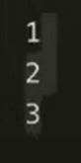

value = next(g)

print(value)

value = next(g)

print(value)

value = next(g)

print(value)



value = next(g)

print (value) # for the 4th time will produce error when no yield is found

print(sum(g)) # Output: 6

print(sorted(g)) # [1,2,3]

* + Example:

def countdown(num):

print("Starting")

while num>0:

yield num

num -=1

cd = countdown(4)

print(next(cd))

print(next(cd))

print(next(cd))

print(next(cd))

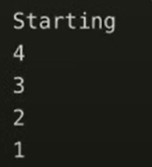

* + Example:

def firstn(n):

nums = []

num = 0

while num < n:

nums.append(num)

num +=1

return nums

mylist = firstn (10)## will take a lot of memory

def firstn_generator(n):

num = 0

while num<n:

yield num

num +=1

print (sum(firstn_generator(10)))## size for this memory is very less comparitively

print(sum(firstn(10)))

* + Example for fibonaci:

def fibonacci(limit):

a, b = 0,1

while a<limit:

yield a

a, b = b, b+a

fib = fibonacci(30)

for I in fib:

print(i)

* + Example:

mygenerator = (I for I in range(10) if i%2 ==0) ## saves a lot of memory

mylist = [I for I in range(10) if i%2 ==0 ]

* + Process and Threads:

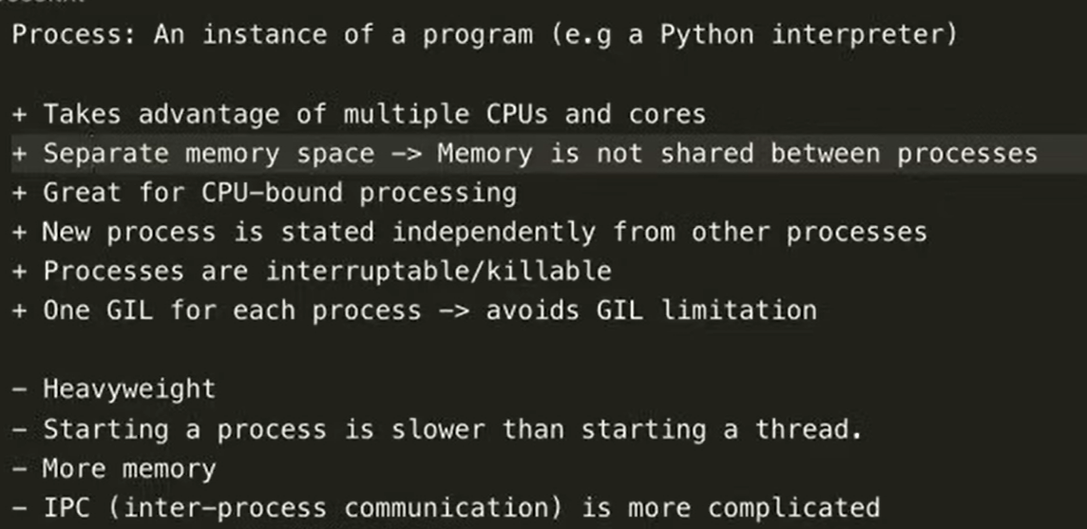

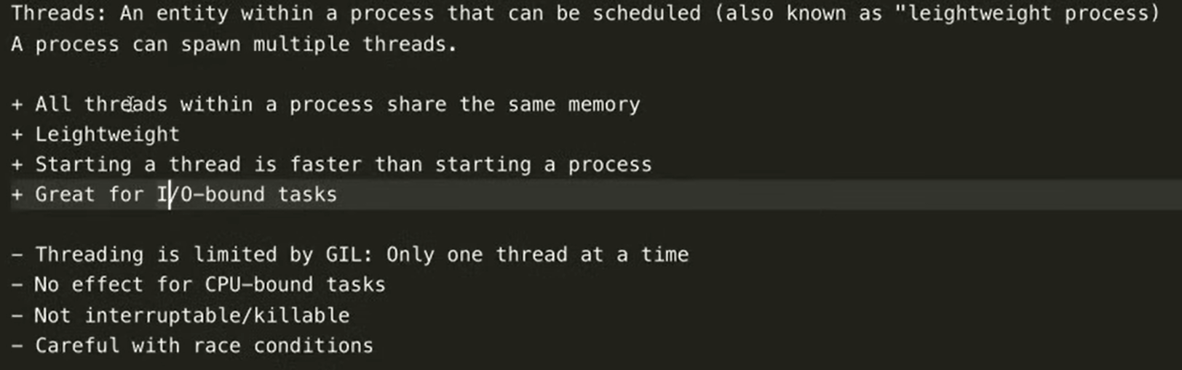

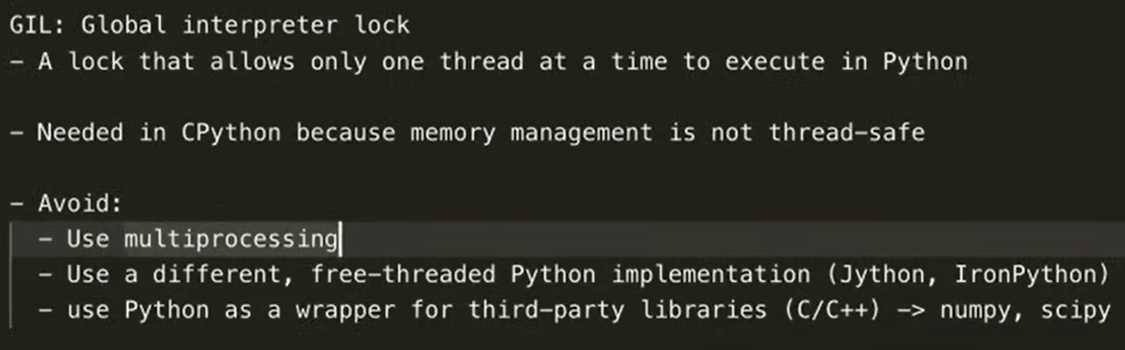

* + Multi Processing:

from multiprocessing import Process

import os

import time

def square_numbers():

for I in range(100):

i*i

time.sleep(0.1)

processes = []

num_processes = os.cpu_count()

for I in range (num_processes):

p = Process(target = square_numbers)

processes.append(p)

for p in processes:

p.start()

for p in processes:

p.join()

print('End Main')

* + Multi Threading:

from threading import Thread

import os

import time

def square_numbers():

for I in range(100):

i*i

time.sleep(0.1)

threads = []

num_threads = 10

for I in range (num_threads):

t = Thread(target = square_numbers)

threads.append(p)

for t in threads:

t.start()

for t in threads:

t.join()

print('End Main')

* + Threading

from threading import thread

import time

database_value = 0

def increase():

global database_value

local_copy = database_value

#processing

local_copy +=1

time.sleep(0.1)# here the second thread is invoked when 1st thread waits

database_value = local_copy

if __name__ == '__main__':

print('start value:', database_value)

thread1 = Thread(target = increase)

thread2 = Thread(target = increase)

thread1.start()

thread2.start()

thread1.join()

thread2.join()

#Output:

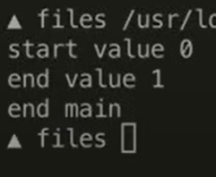

and not 2 as there are 2 threads operating in race condition trying to alter the same variable

* + Corrected Code:

from threading import thread

import time

database_value = 0

def increase(lock):

global database_value

|  |  |
| --- | --- |
| lock.acquire() #used as context manager  local_copy = database_value    #processing  local_copy +=1  time.sleep(0.1)  database_value = local_copy  lock.release() | with lock:  local_copy = database_value    #processing  local_copy +=1  time.sleep(0.1)  database_value = local_copy |

if __name__ == '__main__':

lock = Lock()

print('start value:', database_value)

thread1 = Thread(target = increase, args = (lock,))

thread2 = Thread(target = increase, args = (lock,))

thread1.start()

thread2.start()

thread1.join()

thread2.join()

* + Queues: used for multi threading and processing applications

from threading import thread

from queue import Queue

import time

if __name__ == '__main__':

q = Queue()

q.put(1)

q.put(2)

q.put(3)

#3 2 1 ---->

first = q.get()

print(first) #1

q.task_done() #mark the end of all tasks done with queue

q.join() #waits for all queue to get updated properly

print('end main')

* + Example:

from threading import thread

from queue import Queue, Lock

import time

def worker(q , lock):

while True:

value = q.get()

##processing..

with lock:

print(f'in {current_thread().name} got {value}')

q.task_done()

if __name__ == '__main__':

q = Queue()

lock = Lock()

num_threads = 10

for I in range(num_threads):

thread = Thread(target =worker, args = (q,lock) )

thread.daemon = True

thread.start()

for I in range (1,21):

q.put(i)

q.join()

print('end main')

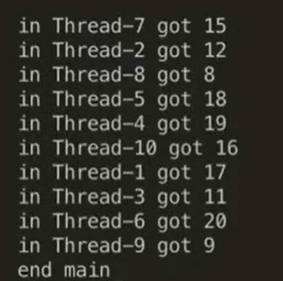

* + Multi Processing:

from multiprocessing import Process, Value, Array

import os

import time

def add_100(number):

for I in range(100):

time.sleep(0.01)

number.value+=1

if __name__ == '__main__':

shared_number = Value('I' , 0)

print('Number at beginning is ', shared_number.value)

p1 = Process(target = add_100, args = (shared_number,))

p2 = Process(target = add_100, args = (shared_number,))

p1.start()

p2.start()

p1.join()

p2.join()

print('number at end is' , shared_number.value)

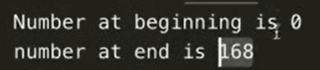

# this happens as there is race condition (2 processes try to read and write into the object at same time). Use lock module to prevent this from happening

* + Corrected code:

from multiprocessing import Process, Value, Array, Lock

import time

def add_100(numbers, lock):

for I in range(100):

time.sleep(0.01)

for I in range(len(numbers)):

with lock:

numbers[i] +=1

if __name__ == '__main__':

lock = Lock()

shared_array = Array('d' , [0.0, 100.0, 200.0])

print('Array at beginning is ', shared_array[:])

p1 = Process(target = add_100, args = (shared_array,lock))

p2 = Process(target = add_100, args = (shared_array,lock))

p1.start()

p2.start()

p1.join()

p2.join()

print('Array at end is ', shared_array[:])

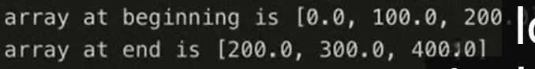

* + Example using queue:

from multiprocessing import Process, Value, Array, Lock

from multiprocessing import Queue

import time

def square(numbers, queue):

for I in numbers:

queue.put(i*i)

def make_negative(numbers, queue):

for I in numbers:

queue.put(-1*i)

if __name__ == '__main__':

numbers = range(1,6)

q = Queue()

p1 = Process(target = square, args = (numbers, q))

p2 = Process(target = make_negative, args = (numbers,q))

p1.start()

p2.start()

p1.join()

p2.join()

while not q.empty():

print(q.get())



* + Process pool: break into smaller chunks for multi processing

from multiprocessing import Pool

def cube (number):

return number*number*number

if __name__ == '__main__':

numbers = range(10)

pool = Pool()

#map , apply, join , close

result = pool.map(cube, numbers)

# with one argument: pool.apply(cube, numbers[0])

pool.close()

pool.join()

print(result)

* + Function Arguments:

def foo(a,b,c):

print(a, b, c)

foo(c =1, a = 2, b= 3)#key word arguments

foo(1, b=2, c=3) #will work

foo (1, b=2, 3) #Error

foo(1, b=2, a = 3) #Error

def foo(a,b,c,d =4) : # d is default argument foo(1,2,3) will assume a default value for 'd'.

def foo (a,b = 2,c,d =4) # Error

def foo(a, b, *args, **kwargs):

print(a,b )

for arg in args:

print(arg)

for key in kwargs:

print(key, kwargs[key])

foo(1,2, 3, 4 , 5, six=6, seven = 7) #1,2 are positional arguments

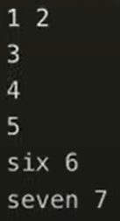

* + def foo(a, b , * , c, d): # '*' forces the value to be key word argument

print(a, b, c, d)

foo(1,2,c =3, d=4)

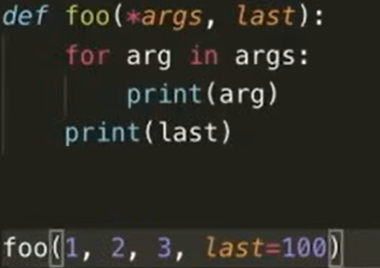

* + Unpacking Arguments:

def foo(a, b, c):

print(a, b, c)

my list = [0, 1, 2]# can also be a tuple .(1,2,3,4) will not work

foo(*my_list)

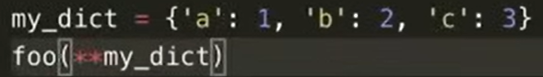

## the above one also works(length and keys should match)

* + Local and Global variables:

def foo():

global number

x = number

number = 3 # will throw an error if global variable is not mentioned

print('number inside funtion:', x)

number = 0

foo()

print( number) # will get updated to 3

* + Parameter Parsing:
    - Call by object and Call by object reference( immutable values inside mutable can be reassigned inside an object)

def foo(x):

x = 4

var = 10

foo(var)

print(var)

# cant be changed

def foo(x_list):

x.append(4)

x.append[0] = 0

my_list = [1, 2, 3]

foo(my_list)

print(my_list)

## immutable data type is changed within a mutable data type

* + ## rebinding will not work

def foo(x_list):

x_list = [0, 1,3] # this will not work

#x_list = x_list + [200, 300] will not work

# x_list += [200, 300] will work

my_list = [1, 2, 3]

foo(my_list)

print(my_list)

* + Astrik Operation:
    - result = 5*7

print(result)

* + result = 5**7(power operation)
  + Create list , tuple or string with repeated elements:

zero = [0, 1] * 5 # can be tuple or string

* + def foo(a, b , *args, **kwargs):

print(a)

for arg in args:

print(arg)

for key in kwargs:

print (key, kwargs[key])

foo(1,2,3,4,5,a=1, seven = 7)

# all parameters after * will be key word arguments (a,b,* , c )

* + Unpacking elements:

def foo(a,b,c):

print(a, b, c)

my_list = [0, 1, 2] # will work for tuple

foo(*my_list)

my_dict = {'a' : 1, 'b':2 , 'c': 3}

foo(**my_dict) # key and number of keys should match

* + Unpacking Containers:

numbers = [1,2,3,4,5,6]

*beginning, last = numbers

print(beginning)

print(last)

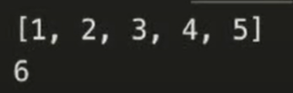

#beginning will be always a list even if numbers was tuple

* + Merging(Unpacking):
    - my_tuple = (1,2,3)

my_set = { 4, 5, 6 }

my_list = [*my_tuple, *my_set]

* + 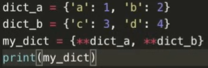

* + Shallow vs Deep Copying:
    - 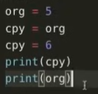

Different values for cpy and org

Mutable variables will get updated

* + 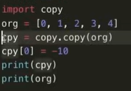

This will create a duplicate list

or list() function or org[:]

* + 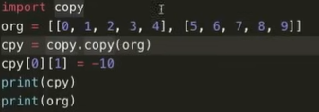

Will edit the first list as copy function is just one level deep

To avoid this we use : copy.deepcopy(org) has to be used

Also use custom object:

* + import copy

class Person:

def __init__(self , name, age):

self.name = name

self.age = age

class Company:

def __init__(self, boss, employee):

self.boss = boss

self.employee = employee

p1 = Person('Alex', 27)

p2 = copy.copy(p1)

company = Company(p1, p2)

company_clone = copy.deepcopy(company)

#otherwise age wont change as copy.copy is shallow copying

company_clone.boss.age = 56

print(company_clone.boss.age)

print(company.boss.age)

p2.age = 28

print(p2.age)

print(p1.age)

* + Context Manager:(resource management)

with open ('notes.txt', 'w' ) as file:

file.write('some todo…..')

file = open('notes.txt', 'w')

try:

file.write('some to do')

finally:

file.close()

* + from threading import Lock

lock = Lock()

lock.acquire()

lock.release()

with lock:

#....

* + Context Manager for class:

class ManagedFile:

def __init__(self, filename):

print('__init__')

self.filename = filename

def __enter__(self):

print('enter')

self.file = open(self.filename, 'w')

return self.file

def __exit__(self, exc_type, exc_value, exc_traceback):

if self.file:

self.file.close()

#add some other part to handle error if in case occured

print('exit')

with ManagedFile('notes.txt') as file:

print('do some stuff…')

file.write('some to doo…')

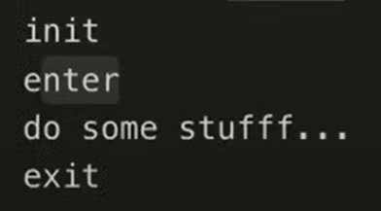

init : ManagedFile calls this class

enter: with calls this method

exit : method gets called when with loop is exited

* + With context manager module:

import contextlib import contextmanager

@contextmanager

def open_manage_file (filename):

f = open(filename, 'w')

try :

yeild f

except:

f.close()

with open_manage_file('notes.txt') as file:

file.write('do something ….')